**Name: Gaurav Kumar Singh**

**Registration Number: 19BCE2119**

**Course: Software Engineering**

**MODEL EXAM**

1. For the super market billing system design the User Interface design using appropriate tools

**Perception:** A comprehensive list of just items purchased, their price and total for submission.

Tabs for detailed description of purchased items.

A search bar to log an item for purchase if QR scanner malfunctions to go through supermarket’s inventory

Customer id to log back to customer purchase.

Transaction Summary in the end.

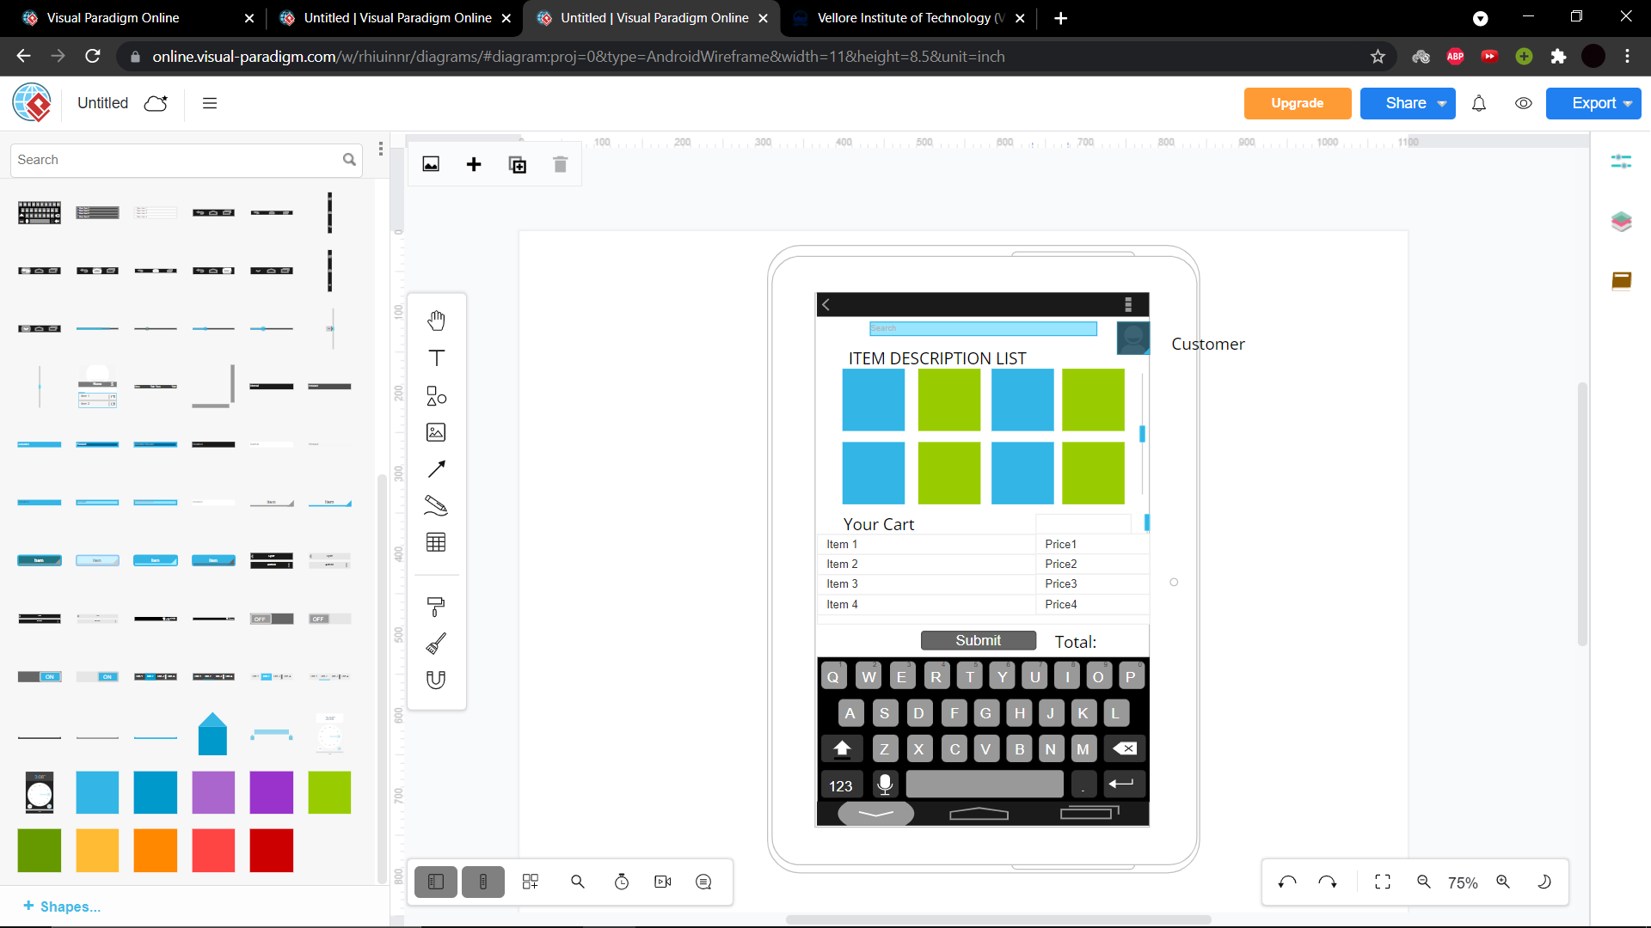

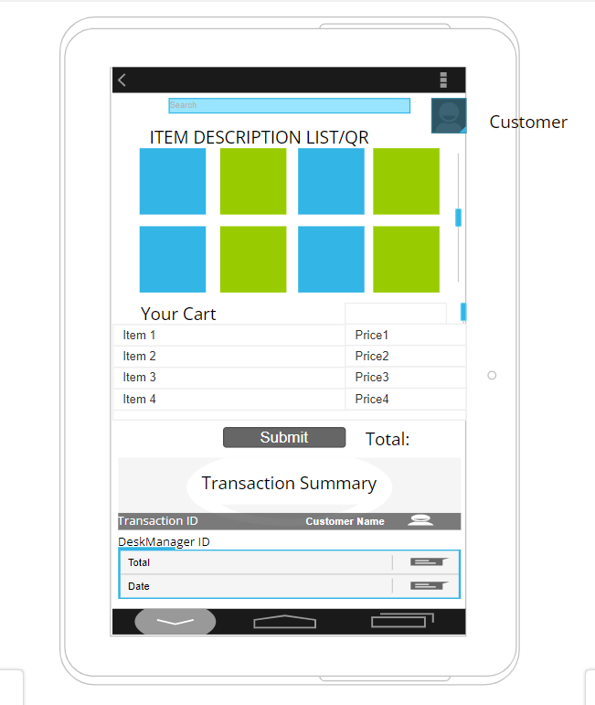

2. For the online supermarket billing system Design the class diagram using the online tools

